University Medical Center of Southern Nevada (UMCSN) CLINICAL TRIALS OFFICE

Prospective Reimbursement Analysis (PRA)
SOP # CTO - 1004.1

Original Date | Review Dates | Revision Dates
New | 3/2015 | Annually

POLICY

- Policy Purpose
  - The purpose of this policy is to:
    - Establish the procedure for determining the billable nature of items and services within the context of a clinical research study at the University Medical Center of Southern Nevada (UMCSN).
    - Outline the process for determining if a clinical research study meets the Centers for Medicare and Medicaid Services (CMS) Clinical Trial Policy (CTP) qualifying criteria for reimbursement related to routine costs of a clinical trial as set forth by the National Coverage Decision (NCD) 310.1.
    - The PRA process begins when all required documents are received in the Clinical Trials Office.
    - The process is complete when the PRA is finalized and documented on the PRA template, approved by the PI and the Clinical Trials Office, and the finalized version is returned to the PI/Study Team and other appropriate parties.

- Policy Statements
  - UMCSN requires that an PRA be performed by the Clinical Trials Office prior to initiating any clinical research study.
  - The PI or their designee must notify the Clinical Trials Office when any changes are made to the protocol, budget, or contract that may impact the billable nature of items and services. This notification should occur at any time during the study lifecycle when such a change occurs.

DEFINITIONS

Conventional Care: Care provided to patients absent a clinical trial. Conventional care is also sometimes referred to as “routine care”. See related “Routine Costs” definition.

Prospective Reimbursement Analysis (PRA): – A Prospective Reimbursement Analysis is a detailed review of the research protocol, related documents, and Medicare coverage guidelines to determine probable reimbursement in the context of the National Coverage Determination (NCD) for Routine Costs in Clinical Trials (310.1).

Qualifying Clinical Trial (QCT): A QCT is a trial that meets the qualifying criteria for reimbursement listed in the Centers for Medicare & Medicaid Services (CMS) National Coverage Determination (NCD) for Routine Costs in Clinical Trials (310.1). The QCT consists of the following information:
- The investigational item or service falls within a Medicare benefit category.
- The trial must have therapeutic intent.
- Trials of therapeutic interventions must enroll patients with diagnosed disease rather than healthy volunteers; trials of diagnostic interventions may enroll healthy patients in order to have a proper control group.
- “Desirable Characteristics” as defined by NCD 310.1.
- Clinical trials that are deemed to be automatically qualified are:
  - Trials funded by NIH, CDC, AHRQ, CMS, DOD, and VA;
  - Trials supported by centers or cooperative groups that are funded by the NIH, CDC, AHRQ, CMS, DOD and VA;
  - Trials conducted under an investigational new drug application (IND) reviewed by the FDA; and
  - Drug trials that are exempt from having an IND under 21CFR312.1(b)(1).

Routine Costs: The CMS Clinical Trial Policy considers “routine costs” to be:
- Items and services that are conventional care
- Items and services to diagnose or prevent complications
- The administration of an investigational item

PROCEDURE/GUIDELINE

Non-Device Study

- The Director of Clinical Research or their designee completes the PRA Template (Tab 2 “QCT Analysis” only) for each non-device study to determine if the research study is a Qualifying Clinical Trial (QCT).
  - Completes questions and information on lines Q1 – Q4 of Tab 2 on the UMCSN PRA Template.
  - Completes questions Q5 – Q12 which answer the Optional QCT criteria.
    - If QCT is qualifying, completes Tab 3 (PRA Billing Grid) of UMCSN PRA Template and Section C of this SOP.
    - If QCT is non-qualifying, the Director of Clinical Research notifies the PI.
      - For any items and services where Medicare or 3rd party payers were to be billed, investigator must identify alternative funding source.
      - If an alternate funding source cannot be identified, forward the protocol materials to the Chief Medical Officer for additional review.

Device Study

- The Director of Clinical Research or their designee completes the MCA Template (Tab 1 only) for each device study.
- Completes questions and information on lines Q1 – Q3 of Tab 2 on the UMCSN PRA Template.
- For device studies initiated by the sponsor on or after January 1, 2015, a NCD will be issued by CMS.
- For device studies initiated by the sponsor prior to January 1, 2015 a LCD will be required by submitting an Investigational Device Submission pack according to Noridian Healthcare Solutions (Jurisdiction E):
- Upon approval by Noridian, completes questions Q3 on Tab 2 and follows steps in Section C of this SOP.
- If device is not covered by Noridian, notifies the PI and study team.
- For any items and services where Medicare or 3rd party payers were to be billed, investigator must identify alternative funding source.

For Both Device and Non-Device Studies

- The Director of Clinical Research or their designee completes the PRA Template Tab 2 (also known as “billing grid”) as follows:
- Identifies all items and services in the clinical research protocol and lists all items and services on the billing grid documenting the CPT, if applicable, and page number of the item and service in the study documentation.
- Identifies items and services that are listed as paid for by the sponsor in the contract and budget and labels these as “S” for sponsor paid on the billing grid.
- Identifies items and services promised free in the informed consent form and labels these as “S” for sponsor paid or “M” for alternative funding source on the billing grid.
- Determines the billable status of the remaining items and services and populates the remaining items on the billing grid to support conventional care (routine costs), non-conventional care items, and services to detect or manage potential research-related complications and research specific procedures as follows:
- Uses the following resources to support conventional care items and services and cites the source on the billing grid under comments: Medicare Policies, Local Coverage Decisions (LCDs), National Coverage Decisions (NCDs), and Relevant Clinical Literature.
- Labels conventional care items and services as “M” for payer on the billing grid.
- Labels research specific procedures and non-conventional care items and services as “S” for paid by sponsor or study account on the billing grid.
- If the Director of Clinical Research or their designee cannot locate a source to support conventional care items and services, collaborates with the PI or their designee to locate references to support conventional care items and services. If a source cannot be located, it shall indicate these items and services as “S” for sponsor paid or “D” for alternative funding source on the billing grid as appropriate.

- The Director of Clinical Research or their designee submits the PRA to the PI for final review and approval. Once the PRA is approved by the PI, the Director of Clinical Research will retain the documented final version and begin the budget development and negotiations.

ATTACHMENTS
Prospective Reimbursement Analysis Template

FOR MORE INFORMATION CONTACT
Director of Clinical Research, Clinical Trials Office

APPROVAL BODIES
Clinical Trials Office

KEYWORDS
Clinical Research

Attachments
PRA Billing Grid
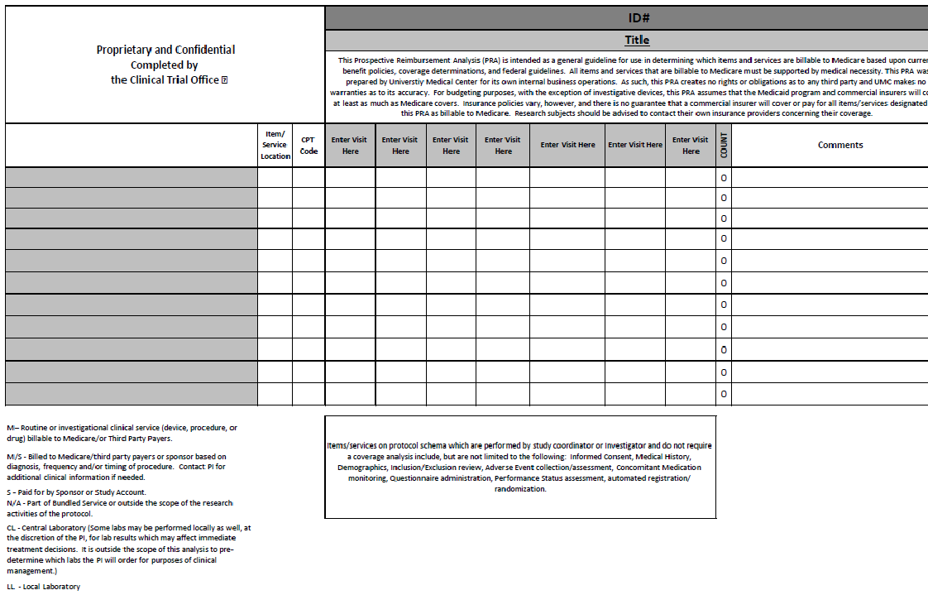

Attachment:
Qualifying Clinical Trial Analysis

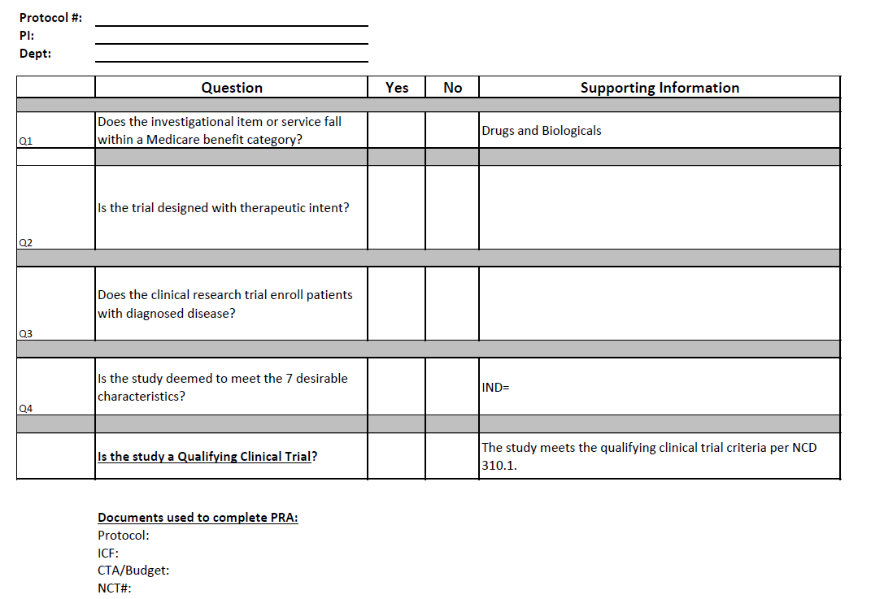

Attachment:
Optional Qualifying Clinical Trial Page
